**Learners have to develop a Report to support the answers to the following questions and suggestions.**

**Objective Questions:**

1. In analyzing the hospital dataset with Power BI, ensure data cleaning to address inconsistencies and missing values before further analysis.

While analyzing the power query I removed the duplicates and checked the data there something is wrong or not.

•Open the power query editor

•Then click on the table icon and in the dropdown select remove duplicates

•After that we go to every table and remove the duplicates accordingly

**A screenshot of a computer

Description generated with very high confidence**

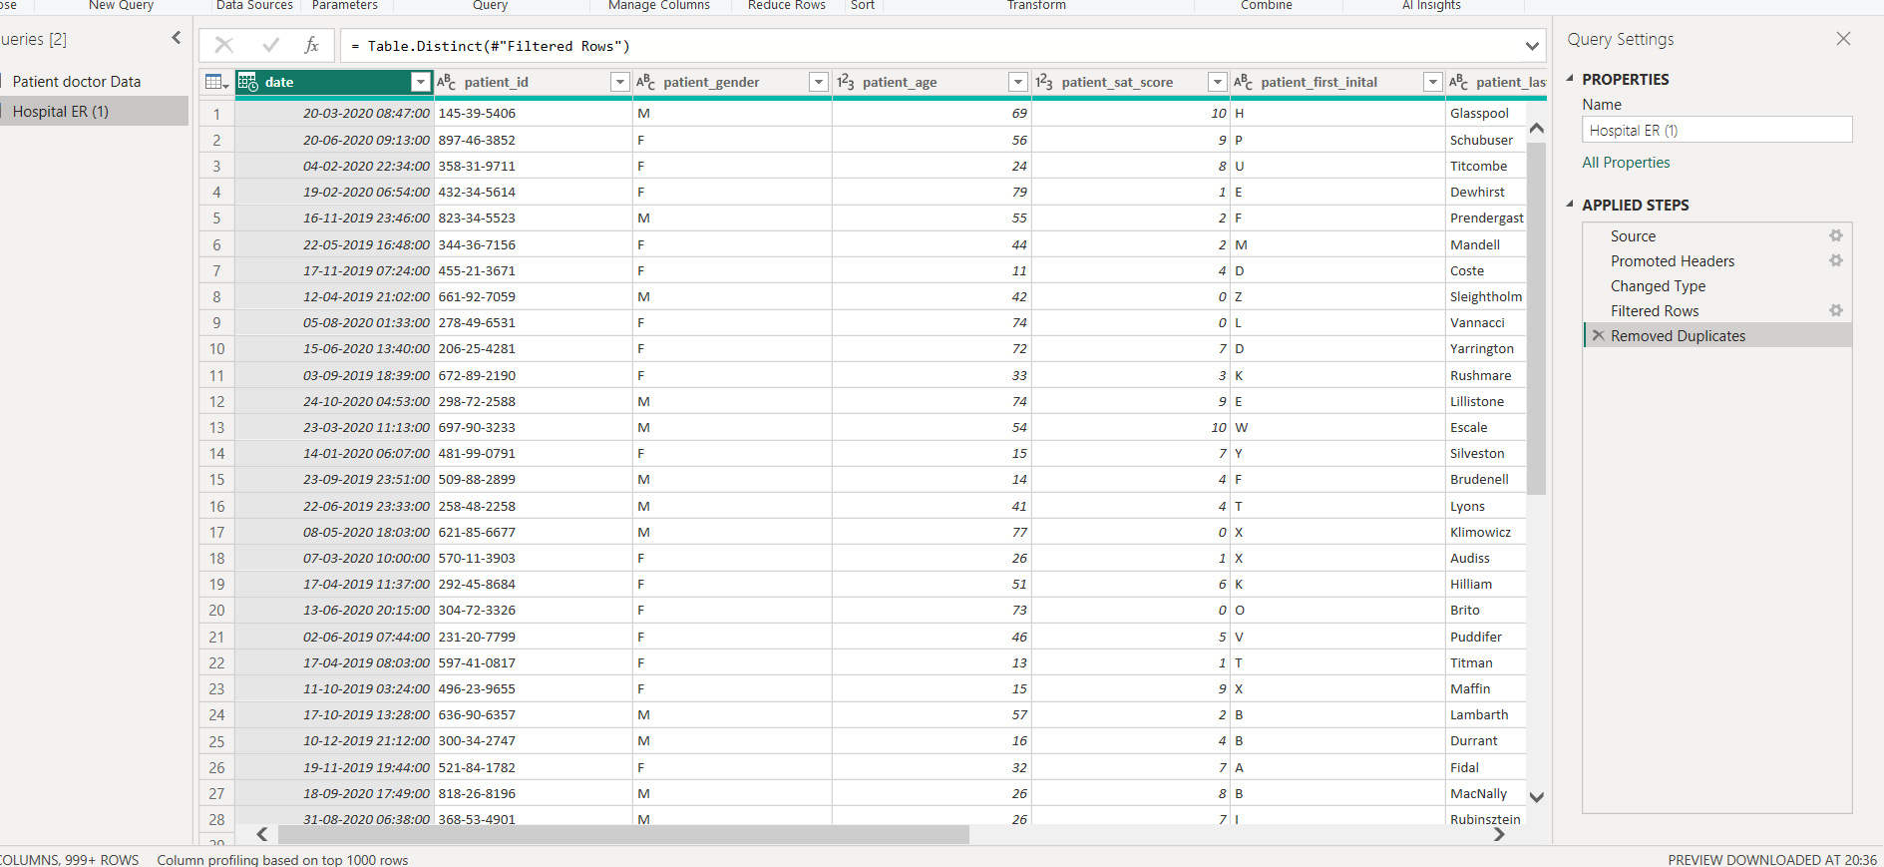

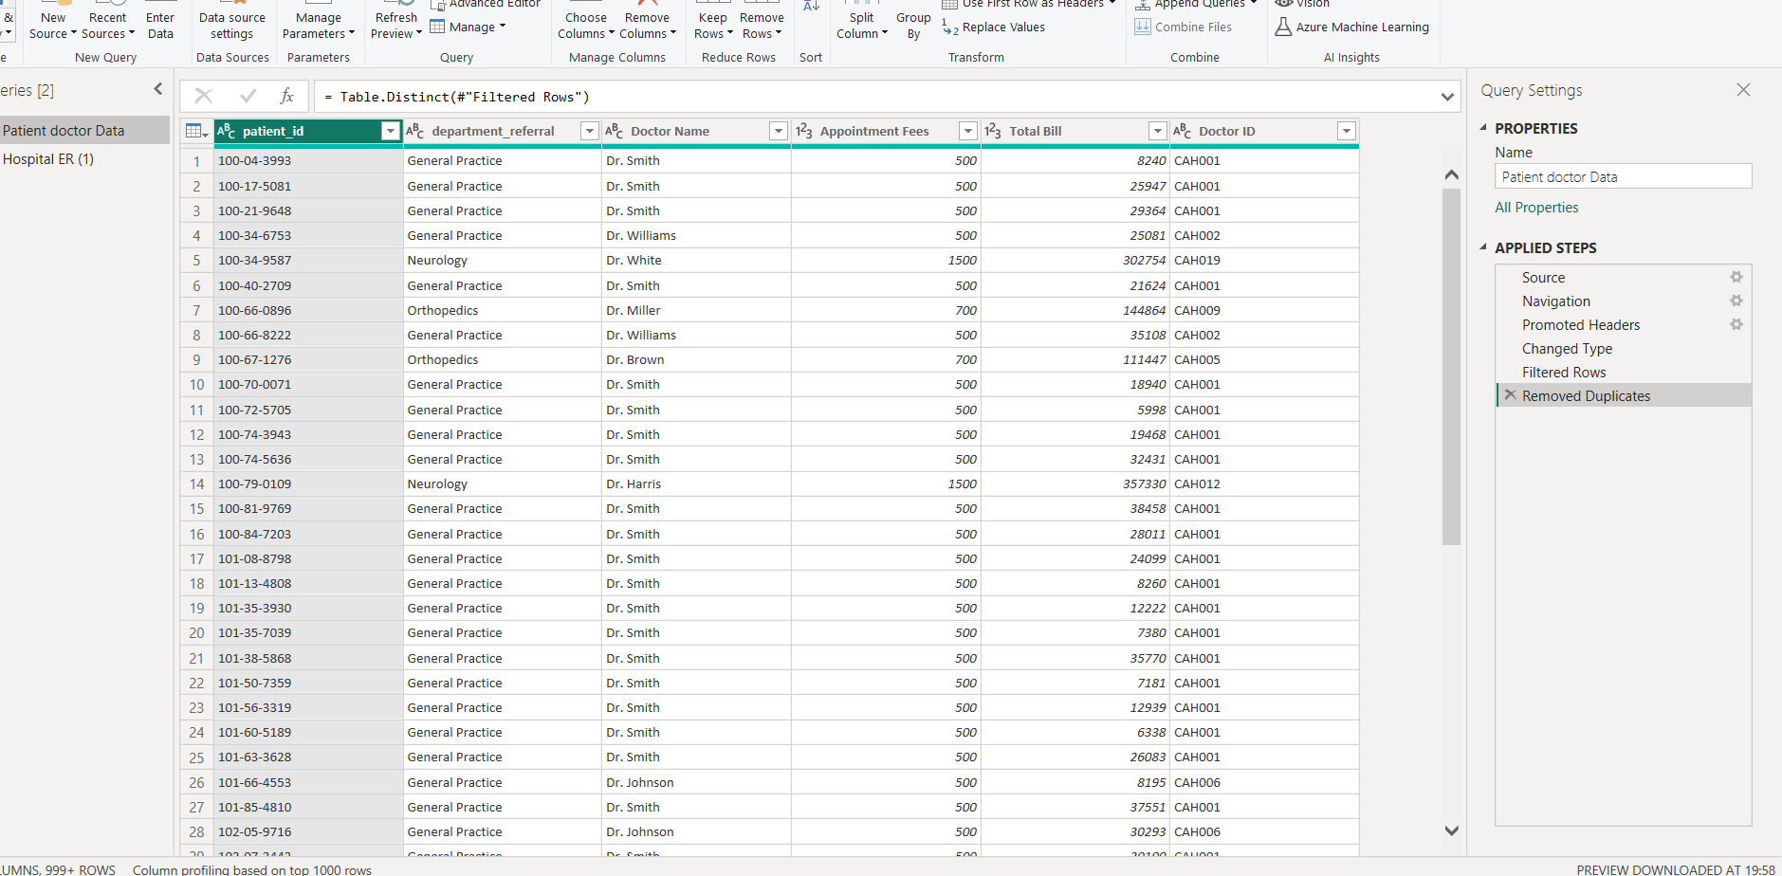

1. **Assess the Average Waiting Time:** Annalise the patient wait times to identify the average duration a patient spends before receiving care.

* **35.35 Average Wait time.**

* The average duration a patient spends before receiving care was about 35.35 minutes. The given image shows the dax used to calculate the average waiting time.



1. **Visits by Department Referral:** Calculate the total number of visits to each department based on referrals to understand which departments are most frequently visited.

* The total number of visits to each department based on referrals to understand which department are most frequently visited was found out first by using simple DAX function. And the further understanding was made that the General Practice (1943) was the most frequently visited department followed by Orthopedics (290).

Total vistied = COUNT('Hospital ER'[patient_race])

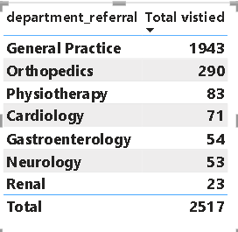

Location- Obj-3 powerBi

1. **Patient Visits by Age Group:** Segregate patient visits according to different age groups to see which demographics utilize healthcare services the most.

* For finding the above question I grouped the age column by using group measure and created a group bin of 10 years of interval.From the finding it was found out that the people from age group of 20 i.e. (20-30) utilizes the healthcare services the most followed by group of 30 i.3.(30-40). While the age group of 0 i.e. (0-10) utilizes the healthcare services the least.

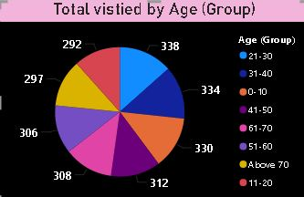

**Most Vistied:**

* Age group 21-30 utilize healthcare services the most.

Location- Obj-4 powerBi

1. Were there any Null values in the data? What would be the best way to handle these Null values and which approach have you opted for?

* While analyzing the given hospital dataset it was seen that there were some null values present in the dataset named Hospital ER in the column named patient sat score I filtered out the null values as their were no specific reasoning provided by the team, so instead of replacing I replaced it as no true basis were made to fill the nulls.

1. Is there any relation between the number of visits and the Gender of the patients?

* From the provided dataset it can be seen that the maximum patient visited in the hospital are male (1306) while only 1206 female visited the hospital.

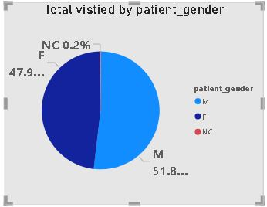

* I have Done the visual where we can see male patient visited the hospital more than the female and NC

Location- Obj-6 powerBi

1. Average Satisfaction by Demographics: Determine the relationship between patient satisfaction scores, their age groups, and racial backgrounds to pinpoint areas for improvement in patient experience.

* From the above graph shown it can be seen that the according to the age group there is declining trend in the satisfaction score of patients which can increased by giving prioritization to senior citizens in place of youths, which would help in increasing the patient’s satisfaction score. While in racial group it can be seen that the Pacific Islanders have highest satisfaction score that is 5.33. While the two or more races race have the least satisfaction score that is 4.83.

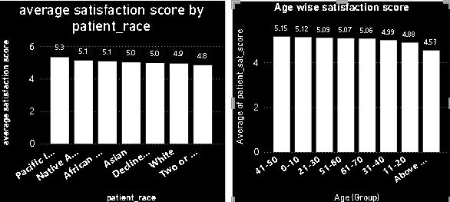

Location- Obj-7 powerBi

* I have done the visualization by using 2 column chart to pinpoint areas for improvement in patient experience.

1. The hospital's managing director seeks to evaluate the revenue of each department to understand how much revenue is generated by each.

The overall revenue that was generated by the hospital was about 509M. And among all the department associated in the hospital, Orthopedics has generated the highest revenue which is about 173M followed by General Practice department that is around 164M. the lowest revenue was generated by the Renal department that’s only 5M.

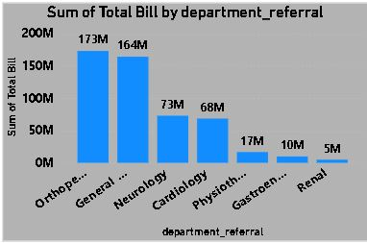

Location- Obj-8 powerBi

* This table is showing the revenue of each department to understand the revenue is generated by each.

1. Which department is charging the highest appointment fees in general? Use an aggregation DAX function to solve this question.

* The Neurology department is charging the highest appointment fees in general that is around $1,500. The second highest appointment fees is charged by Cardiology that is $1,200. While the lowest appointment fees is of Renal and General practices department that is arounf $500

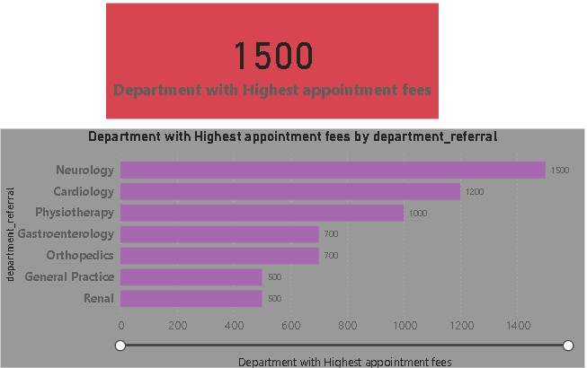

* Department with Highest appointment fees = MAX(Sheet1[Appointment Fees])

Location- Obj-9 powerBi

1. Create a tabular visualization in the Report view which consists of Month-wise total visits in the hospital. Add a third column in the table that consists of the previous month’s total visits for each month’s row. Also, include a column that states whether the visits in a month are greater than that of the previous month's visits.

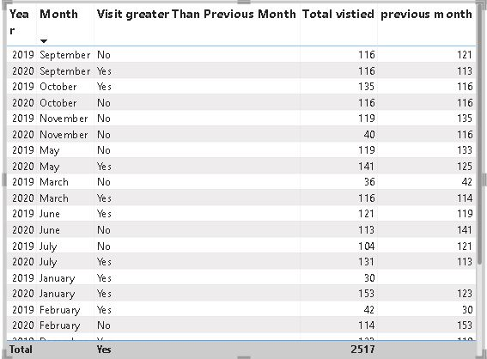

Location- Obj-10 powerBi

* Through this table to show Month-wise Total visit in the hospital. Including previous month’s total visit for each month. And visit greater than Previous Month.

1. Using ‘Calculate’ and a row iteration DAX function calculate the total number of patients who have visited Dr. Smith.

* The total number of patients who have visited Dr. Smith are 1592. The below pic shows the DAX function used to calculate the given statement.



1. Calculate the average age of the patients who visit the Orthopedics department. Will the approach used to calculate this metric be different if the requirement had been all departments’ average age?

* The average age of the patients who visit the orthopedics is around 39.02. Whereas the average age of patients in all department is 39.94. The formulas used to determine the above statement is as follows:

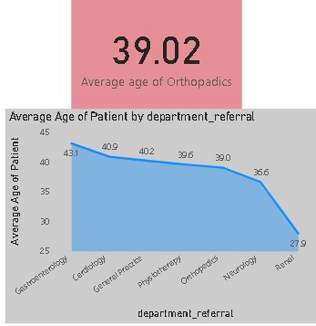

* Average age of Orthopedics = CALCULATE(AVERAGE('Hospital ER'[patient age]),Sheet1[department referral]="Orthopedics")

* Using this calculation to extract the average of Orthopedics.

Location- Obj-12 powerBi

1. Were there any data format issues in the data, and if there were/are how you handle them?

**There were some data format issues in the given dataset which was changed in different ways:**

* The data type of the appointment fees and the total bills were in the text form.
* The date column was given along with the time which I split it using split by column to get two different columns of date and time.

1. When we add a column in Power Query what’s the code that comes in M language in the formula bar? What do you know about M-query?

**=** Table.AddColumn(#"Previous Step", "NewColumnName", each Some Expression)

* + M-query is an acronym of word “mashup” query. It is used to query a large amount of data from data source. It is used during the data import which is the first step where data gets imported in data model of power bi desktop where the queries are using M in the background.

**Subjective Questions**

1. What is the relation between patient wait time and satisfaction scores?

* We can say that the average patient wait time is inversely proportional to satisfaction score, in many cases its seen that the less average time wait has high satisfaction score as compared to the patient whose wait time is higher. It can be seen that low wait time has a score of 8-10 while high wait time has score rate of 0-3.

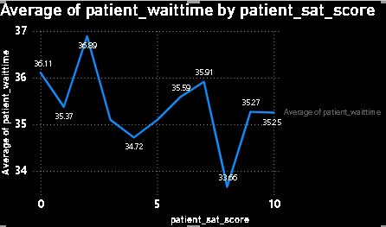

* Analysis: after using this line chart we can clearly see that where sat score is high then wait time is less where the wait time is high then sat score is less

Location- Sub-1 powerBi

1. How do patient demographics affect the frequency of visits to different department?

* From the given data set it can be that the majority of the patient coming to the hospital are male that is around 1306 while only 1206 females visit the hospital. On the basis of the ages of patients the maximum number of patients that visits the hospital belongs to the age group of 20 (20-30).

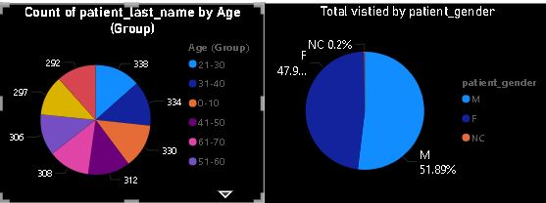

Location- Sub-2 powerBi

1. Is there a noticeable trend in the volume of patient visits throughout the year?

* The blue slice, labeled “2020” is larger and accounts for 47.64% of the total visitors. The green slice, labeled “2019” is smaller and accounts for 52.36% of the total visitors.

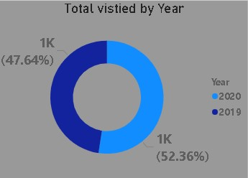

Location- Sub-3 powerBi

1. Which age groups report the highest and lowest satisfaction scores?

* The age group of (40-50) shows the highest satisfaction score i.e. 5.15 While the age group of (Above 70) shows the lowest satisfaction score i.e. 4.53. (used average satisfaction score vs. age group)

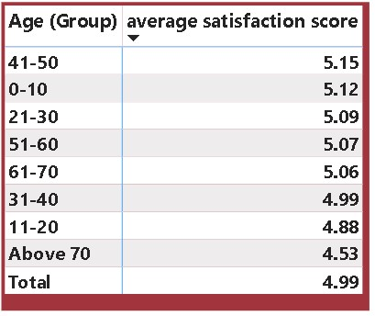

* Age above 70 is the Lowest Satisfaction Score.
* Age Group 41-50 is the Highest Satisfaction Score.

Location- Sub-4 powerBi

1. Say someone outside of the hospital claims that there is racial or gender-based discrimination in the hospital, how will you identify whether the claim was right or not?

* + So, if someone outside of the hospital claims that there is racial or gender-based discrimination in the hospital, it can be said that the above claim was not true as it can be that second majority of the patient in the hospital visited are African American, not only that but more than 5 racial community comes here for the treatment. Not only by racial but along with that the female patients are in good number which is only 100 less than that of male patients. So the hospital is non-biased in terms of race and gender of patients.

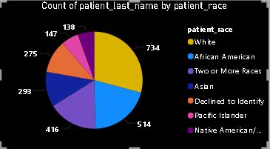

Location- Sub-5 powerBi

1. The hospital management intends to offer discounts to patients. How should these offers/discounts be assigned to patients, on what basis, and why?

The hospital management should offer discounts to the patients of the age group of 60 (60-70) & (above 70). As they are seniors and need more assistance as compared to the youth generations, thus it will help in increasing the satisfaction score of patients and there can be increase in the patients of this age group also.

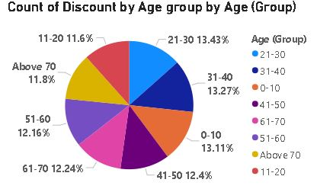

Location- Sub-6 powerBi

* I used this pie chart to show discount by age group on the basis of age we can offer discount to the patients.

1. The hospital has a budget to hire 2-3 new doctors. They have asked for your suggestions on which departments they should hire.

* If the hospital has a budget to hire 2-3 new doctors, they should be hired in the Orthopaedics, General Practice and Physiotherapy, as they have highest numbers of visitors and a smaller number of doctors. Thus, it will help in increasing the revenue as these departments are busier as compared to others.

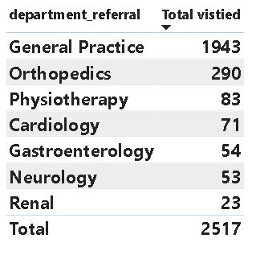

Location- Sub-7 powerBi

1. Is the hospital profitable? How will you determine the profitability?

**Yes the hospital is profitable because it is generating 509 million dollars**

**And the maximum appointment fees is 1500 dollar**

1. Any Department for which the waiting time is oddly large?

* The average waiting time of the renal department is oddly large as compared to other departments which is around 37.43 minutes. Which is followed by Physiotherapy department which is 37.04 minutes. While the cardiology has the least waiting time that is 33.25 minutes

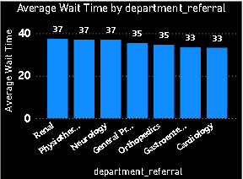

Renal Department is the waiting time is oddly large.

Location- Sub-9 powerBi

1. Come up with strategies to provide discounts to the patients.

* The strategies we could use to provide discounts to the patients should be like giving 50% discount in the appointment fees of doctor to all the seniors category of 60 (60-70) & Above 70 And we can also provide extra free facilities to the senior citizens like massage area or free regular tests. Thus, it will not increase the number of patients but also increase the satisfaction score of patients by attracting new patients.

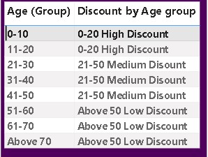

Location- Sub-10 powerBi

**Discount:**

I did use Age Group to provide discount to the patients. Age between 0-20 High Discount because there can be very less chance to be major diseases. And the Age between 21-50 Medium discount because there can be more chance to be major diseases and age above 50 there will be high chance. Therefore I provide the age wise discount to the patients.

1. Say you need to align the doctors of the “General Practice” department to work in one of the two shifts, how will you identify what will these two shifts' timings be, and how will you divide the doctors in these two shifts? And also will this 2 shift policy be helpful for the hospital?

▪ This is not relevant with the data given.

No this is not good that one or two doctor will do 2 shift in a day.

1. What do you understand by PowerBI gateway? What are its use cases?

* Power BI Gateway is a crucial component in the Power BI ecosystem that facilitates secure data transfer between on-premises data sources and Power BI services hosted in the cloud. It acts as a bridge between the data sources that are behind corporate firewalls or in private networks and the Power BI service in the cloud.
* Function and uses:
* **Data Refresh**: One of the primary use cases of Power BI Gateway is to enable scheduled data refreshes for datasets stored in on-premises or private network data sources. By configuring the gateway, users can ensure that their Power BI reports and dashboards reflect the most up-to-date data from their internal systems.
* **Direct Query**: Power BI Gateway allows users to connect to on-premises data sources using Direct Query mode, enabling real-time data analysis without needing to move or replicate data into the cloud. This is particularly useful for scenarios where data freshness is critical, such as financial reporting or monitoring operational metrics.

1. How would you approach this problem, if the objective and subjective questions weren't given?

* If the objective and subjective question weren’t given, I would have made a two-report tab. In one I would have made doctor’s tab and patient’s tab. Where I would have shown the same thing which is shown in this project. But I would have a different approach like how could the waiting time can be reduced, how we can improve the satisfaction score rating, etc.

1. Can you analyze and write the type of relationship between the doctor id and department, is it one-to-one?

* There is a one-to-many relationship between the doctor id and department, as each doctor is assigned to single department. Like one doctor is associated to single department. But there a department have multiple doctors.

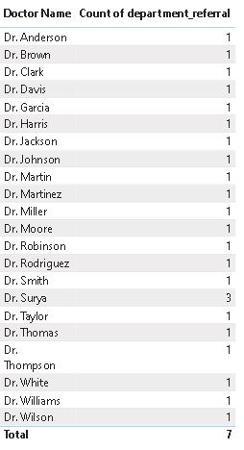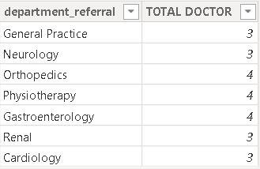

Location- Sub-14 powerBi

C:\Users\ncr\Pictures\Formula for 14th.JPG

I used this approach to show the relationship between Doctor and department and we can clearly see the one – to many relationship between doctor and department.

**Reports**

